Design and implimentation of self purifiing water bottle using UV radiation method

Sirbu Artur

Universitatea Technica a Moldovei

*artur2003s.ass@gmail.com*

***Summary-* This research paper introduces a self-purifying water bottle designed to address the global challenge of providing clean and safe drinking water. The bottle utilizes UV radiation technology for efficient water purification on-the-go. By neutralizing harmful microorganisms without chemicals or additional filtration systems, the UV radiation method offers a convenient and cost-effective solution. The paper presents a comprehensive design and implementation process, including considerations for bottle design, UV radiation source selection, power supply, and control mechanisms. The chosen ATtiny85 microcontroller ensures efficient operation, while the integration of touch buttons and LED indicators enhances user experience. The housing design focuses on practicality and incorporates materials that reflect UV light. The software code provided demonstrates basic LED control and touch button interaction. This self-purifying water bottle has the potential to revolutionize water purification, providing a portable, efficient, and chemical-free method for ensuring the safety of drinking water, particularly in areas with limited access to clean water sources.**

**Key words: Self-purifying water bottle, UV radiation, Water purification, Portable water treatment**

***Introduction***

Access to clean and safe drinking water is a fundamental necessity for human health and well-being. However, a significant portion of the global population still lacks access to reliable sources of potable water, leading to the outbreak of waterborne diseases and related health issues. In recent years, various technologies have been developed to address this challenge, and one such innovative solution is the self-purifying water bottle utilizing UV radiation. This research paper aims to design and implement a water bottle that integrates UV radiation technology to provide an efficient and portable method for purifying water on-the-go.

The UV radiation method has gained considerable attention due to its ability to neutralize harmful microorganisms present in water, such as bacteria, viruses, and protozoa, without the use of chemicals or additional filtration systems. By leveraging the power of ultraviolet light, this self-purifying water bottle offers a convenient and cost-effective solution to ensure the safety of drinking water, especially in situations where access to clean water sources is limited or compromised.

The primary objective of this research paper is to present a comprehensive design and implementation process for the self-purifying water bottle using UV radiation. The study will explore the necessary considerations in terms of bottle design, UV radiation source selection, power supply, and control mechanisms to ensure effective purification while maintaining user convenience and portability. Furthermore, the research will focus on evaluating the performance of the water bottle through extensive testing and analysis, comparing its purification efficiency with existing water treatment methods.

The outcomes of this research hold significant potential for addressing the water contamination challenges faced by individuals, travelers, and communities in various settings. The self-purifying water bottle has the potential to become a valuable tool in emergency situations, outdoor activities, and regions with limited access to clean water sources, improving the overall quality of life and reducing the risks associated with waterborne diseases.

In conclusion, this research paper will contribute to the field of water purification technology by presenting a detailed design and implementation process for a self-purifying water bottle using UV radiation. The innovative solution has the potential to revolutionize the way we ensure the safety of drinking water, offering a portable, efficient, and chemical-free method for water purification. By addressing the pressing need for clean drinking water, this research aims to make a positive impact on global health and well-being.

***Content of the work***

The design and implementation of a self-purifying water bottle utilizing UV radiation represents an innovative approach to address the global challenge of providing clean and safe drinking water. This segment will delve deeper into the theoretical foundations of water purification using UV radiation and the advantages it offers, while also discussing the necessary considerations for the design and implementation of the self-purifying water bottle.

I. Gathering Theoretical Information

Water Purification with UV Radiation: Water purification using UV radiation is an effective and reagent-free method that can neutralize a wide range of pathogens and bacteria. The bactericidal effect of UV radiation depends on factors such as the exposure time and the wavelength of the UV radiation. When water is exposed to UV rays, the DNA molecules of microorganisms undergo chemical reactions, resulting in irreversible damage and the destruction of cytoplasmic membranes and protective cell envelopes [1]. This method offers several advantages for water purification:

1. Effectiveness: UV radiation can target various types of pathogenic microflora, including spore-forming and vegetative bacteria, viruses, and protozoa [1]. It provides a comprehensive disinfection solution that can significantly reduce the risk of waterborne diseases.
2. Environmental Safety: UV radiation is a reagent-free method, eliminating the need for chemicals such as chlorine. It does not introduce any harmful byproducts or residual chemicals into the water, making it an environmentally friendly approach.
3. Water Quality: UV radiation does not alter the chemical composition or taste of the water, ensuring that the purified water retains its original qualities. There is no risk of over chlorination or the formation of disinfection byproducts.
4. User-Friendly and Low Maintenance: UV systems are relatively simple to operate and require minimal maintenance. Once installed, they provide continuous disinfection without the need for frequent adjustments or monitoring.
5. Operational Efficiency: UV systems have low operational costs compared to other water treatment methods. They consume less energy and have lower maintenance requirements, making them cost-effective solutions in the long run.

UV Wavelength and Sources: The efficiency of water purification with UV radiation is influenced by the specific wavelength of UV light used. UV light is categorized into three regions based on wavelength: UVA (320 to 400 nm), UVB (280 to 320 nm), and UVC (200 to 280 nm) [2]. The most effective germicidal wavelength for water disinfection falls within the UVC range, particularly around 260 to 265 nm [3, 4]. This wavelength is highly absorbed by the DNA of microorganisms, leading to their inactivation.

To generate the required UV radiation, UV-LEDs (Ultraviolet Light-Emitting Diodes) are often used as the light source. UV-LEDs offer precise control over the emitted wavelength, making them suitable for targeting the germicidal range. They also have advantages such as compact size, durability, and low energy consumption, making them ideal for portable applications like a self-purifying water bottle.

In the context of designing and implementing a self-purifying water bottle, the choice of UV source and its integration into the bottle's structure is a crucial consideration. Factors such as power supply, UV intensity, exposure duration, and the need for control mechanisms should be carefully addressed to ensure optimal performance and user convenience.

By incorporating these theoretical foundations, the design and implementation process of the self-purifying water bottle can progress effectively. The next steps involve practical aspects such as engineering the UV radiation system, developing the power supply mechanism, integrating safety measures, and assessing the performance through comprehensive testing and analysis.

***II* Hardware Development and UV Light Source Selection**

The design and implementation of a self-purifying water bottle utilizing UV radiation represents a significant advancement in water purification technology. This segment focuses on the hardware development process, including the schematic design, printed circuit board (PCB) layout, and the selection of the UV light source. The integration of touch buttons and LED indicators further enhances the user experience. The following sections provide an overview of the design process, the hardware components used, and the selection of the UV light source.

Schematic and PCB Design: The schematic and PCB layout for the self-purifying water bottle were developed using EasyEDA, a user-friendly electronics design software. The schematic design includes the integration of a touch button based on the TTP223 integrated circuit, allowing convenient operation for the user. Figures 1, 2, and 3 showcase the schematic and PCB design on both sides.

Touch Button Integration: To enhance the user experience and provide seamless control, a touch button based on the TTP223 integrated circuit was incorporated into the design. This touch button technology enables intuitive and reliable user interaction, making it easy to activate the self-purification process.

LED Indicators: For improved user feedback, three LEDs were integrated into the design and placed on top of the bottle cap. These LEDs serve as indicators to provide visual cues regarding the status of the purification process. The LEDs illuminate different colours to signify power on/off, purification in progress, and completion of the purification cycle.

UV Light Source Selection:

The effectiveness of the self-purifying water bottle heavily relies on the UV light source used. After careful evaluation, the OP255-10P-SM UV light source from OPTAN manufacturer was chosen for its exceptional performance and reliability. This UV light source emits ultraviolet radiation within the germicidal range, specifically targeting the wavelength required for efficient water disinfection.

Power Source:

To ensure portability and convenience, the power source for the self-purifying water bottle is provided by CR1602 batteries. These compact and durable batteries were selected for their suitable power capacity and compatibility with the design requirements. The power source plays a crucial role in sustaining the operation of the UV light source and other integrated components throughout the purification cycle.

The hardware development phase of the self-purifying water bottle has been successfully accomplished, incorporating a touch button interface, LED indicators, and an optimal UV light source. The integration of these components ensures user-friendly operation and efficient water disinfection. The next steps involve the implementation of the electrical and mechanical aspects, followed by thorough testing to validate the performance and functionality of the self-purifying water bottle.

Programable Integrated Circuit:

In the design and implementation of the self-purifying water bottle, the choice of a programmable integrated circuit (IC) is crucial for controlling various functions and ensuring efficient operation. For this project, the ATtiny85 microcontroller from Microchip was selected due to its versatile features and suitability for low-power applications.

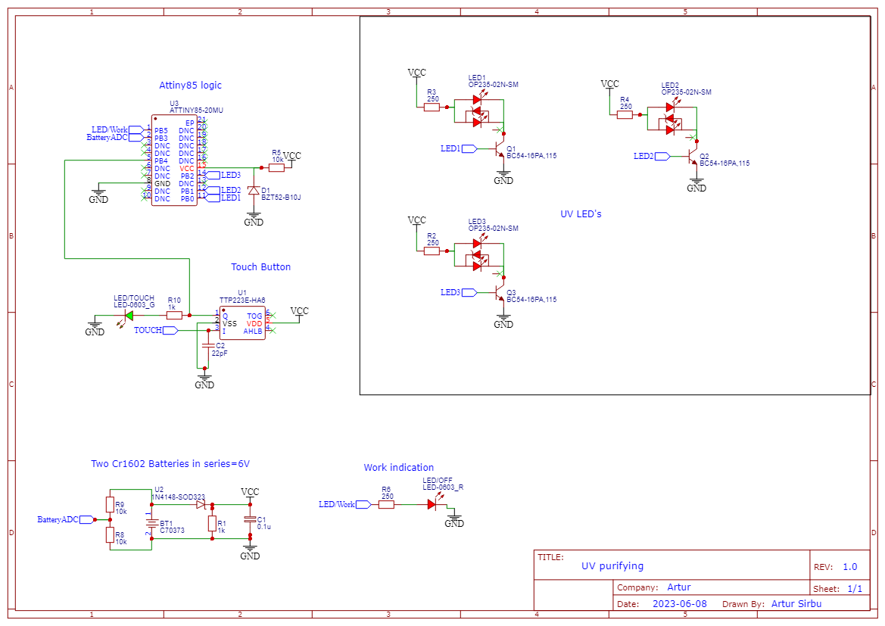The ATtiny85 microcontroller offers a compact size and low power consumption, making it an ideal choice for portable devices like the self-purifying water bottle. It has 8KB of flash memory, allowing for the storage of the necessary program code. Additionally, it features 512 bytes of EEPROM and 512 bytes of SRAM, providing ample space for data storage and manipulation.

*Fig 1 Schematic*

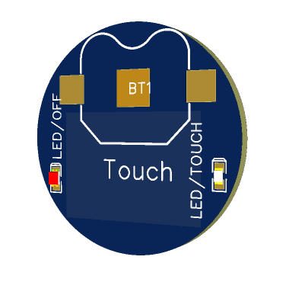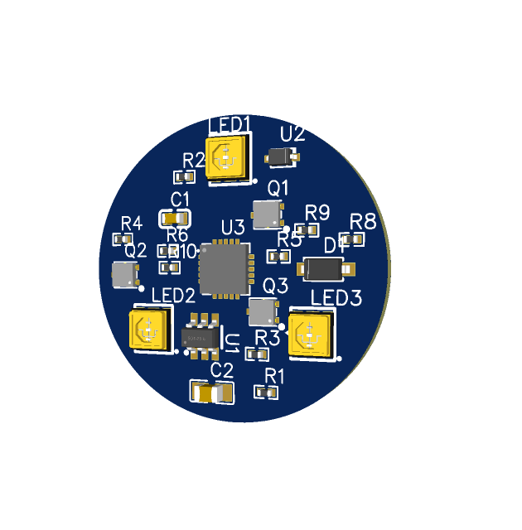

*Fig 2, 3 PCB design both sides*

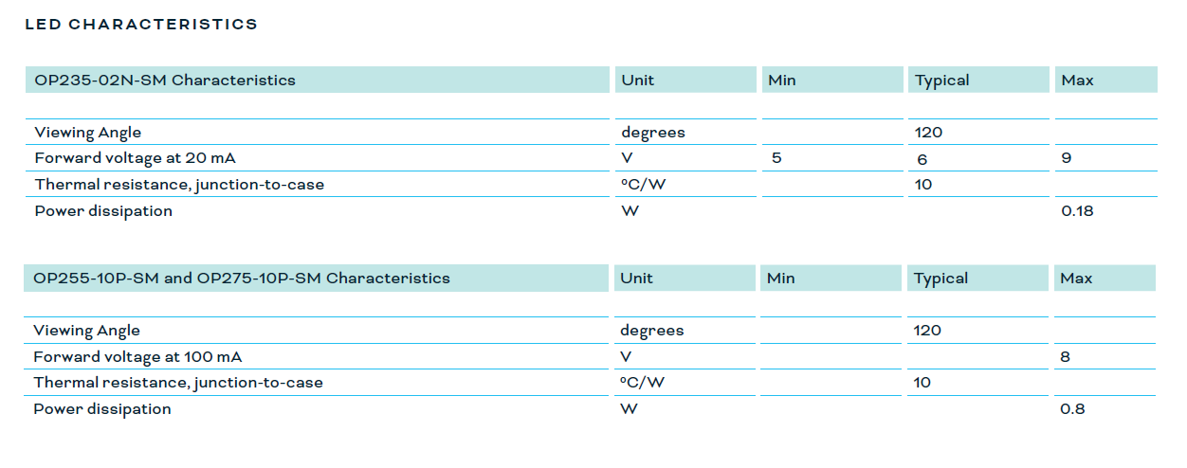

*Fig 4 from datasheet characteristics of selected UV LEDs*

**III. Concept design of housing and Software**

In addition to the hardware development discussed earlier, the concept design of the housing and the software implementation are crucial aspects of the self-purifying water bottle. This section will outline the concept design of the housing and provide an overview of the software code used for controlling the LEDs and touch button functionality.The software code provided below demonstrates the basic functionality of the self-purifying water bottle's LED control and touch button interaction. The code is written in the C++ (Arduino IDE) programming language and utilizes specific pin assignments for the LEDs, touch button, and other components. The code initializes the necessary pin modes for the LEDs, touch button, and battery ADC (Analog-to-Digital Converter). The loop function controls the behaviour of the LEDs based on specific timing conditions and touch button input. Initially, all LEDs are set to high (ON) for a defined wait time(10min). After this duration, the LEDs are turned off (LOW) for a specific work time (5min.). If the touch button is pressed during the wait time, the LEDs are also turned off. This basic code structure can be further expanded to include additional features and functionality as required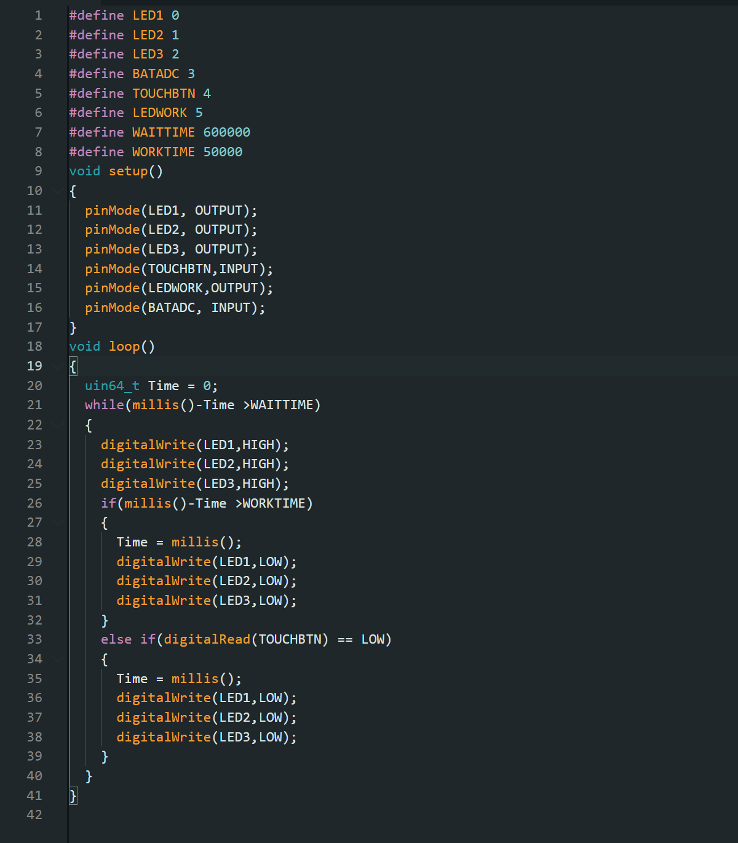

Concept Design of Housing: 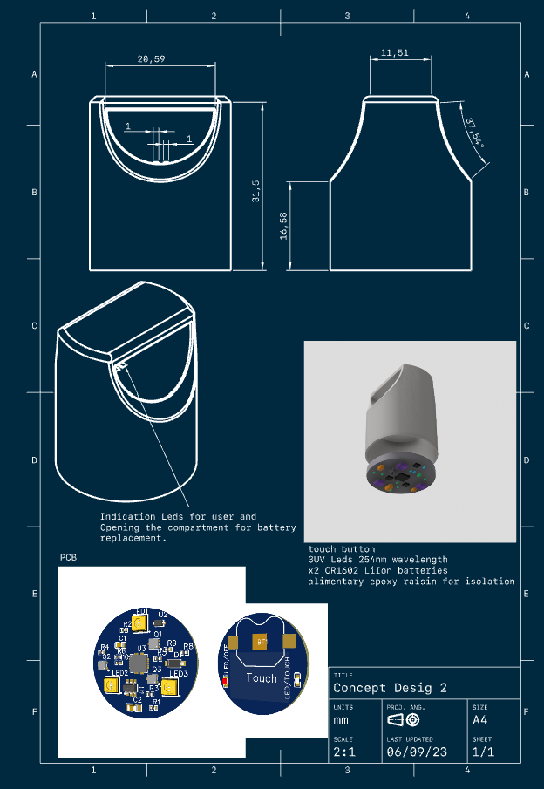The housing of the self-purifying water bottle is designed to be compact, ergonomic, and user-friendly. It aims to provide a comfortable grip while ensuring the protection and integration of the various components. The concept design focuses on practicality, aesthetics, and ease of use, allowing for easy refilling and effortless operation also should be noticed that materials must be that reflect UV light for example polished aluminium the PCB is in the cap of the bottle and is protected from water by epoxy raisin

**Conclusion**

The design and implementation of a self-purifying water bottle using UV radiation technology represents an innovative solution to address the global challenge of providing clean and safe drinking water. This research paper has presented a comprehensive design and implementation process for such a water bottle, incorporating theoretical foundations, hardware development, and software implementation.

The use of UV radiation for water purification offers several advantages, including effectiveness against a wide range of pathogens, environmental safety, maintenance simplicity, and operational efficiency. The selection of the UV light source, specifically targeting the germicidal range, ensures optimal disinfection performance. The integration of touch buttons and LED indicators enhances the user experience and provides visual cues regarding the purification process.

The hardware development phase successfully accomplished the schematic and PCB design, incorporating a touch button interface, LED indicators, and an optimal UV light source. The chosen ATtiny85 microcontroller from Microchip ensures efficient control and operation of various functions while maintaining low power consumption and compact size.

The concept design of the housing focuses on practicality, aesthetics, and ease of use, ensuring protection and integration of the components. Materials that reflect UV light, such as polished aluminium, are utilized to enhance the effectiveness of the UV radiation process.

The software implementation utilizes the Arduino IDE and the C++ programming language to control the LEDs and touch button functionality. The provided code demonstrates the basic behaviour of the self-purifying water bottle, which can be further expanded to include additional features and functionality.

Overall, this research paper contributes to the field of water purification technology by presenting a detailed design and implementation process for a self-purifying water bottle using UV radiation. The innovative solution offers a portable, efficient, and chemical-free method for water purification, addressing the pressing need for clean drinking water and making a positive impact on global health and well-being.

*Bibliography*

*1. https://rbkv.ru/s/news/20180702084434*

2. Guerrero-Beltrán JA, Barbosa-Cánovas GV. 2004. Review: advantages and limitations on processing foods by UV light. Food Sci Technol Int **10**:137–147. doi: 10.1177/1082013204044359.

3. Kalisvaart BF. 2004. Re-use of wastewater: preventing the recovery of pathogens by using medium-pressure UV lamp technology. Water Sci Technol **50**:337–344.

4. Sharma G. 2000. Ultraviolet light. Encyclopedia Food Microbiol **3**:2208–2214.